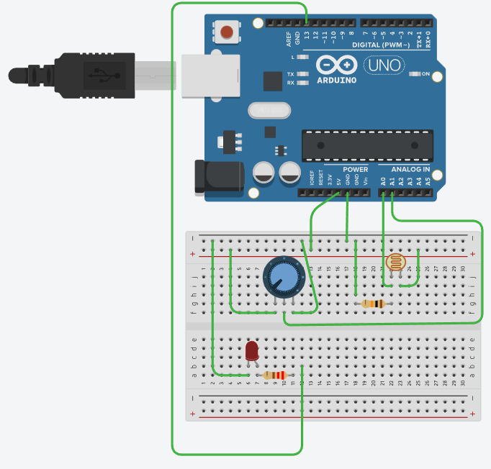

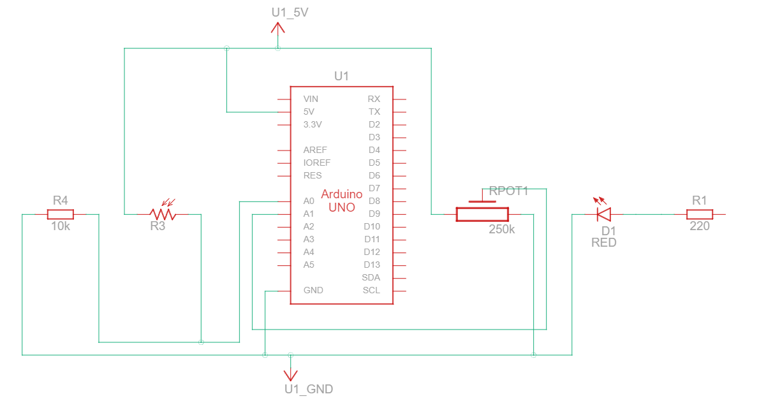

int LED=13;

int Poti = 1;

int LDR=0;

int cnt=0;

void setup (){

pinMode(LED, OUTPUT);

Serial.begin(9600);

}

void loop() {

if(analogRead(LDR)>analogRead(Poti)) cnt=0;

if(analogRead(LDR)<analogRead(Poti)) cnt++;

if (cnt>300)

{

digitalWrite(LED,HIGH);

do{

delay(1000);

}while(analogRead(LDR)<analogRead(Poti));

cnt=0;

digitalWrite(LED,LOW);

}

delay(10);

}